**Mustafa Ahsan Khan**

**I230549**

Q1) 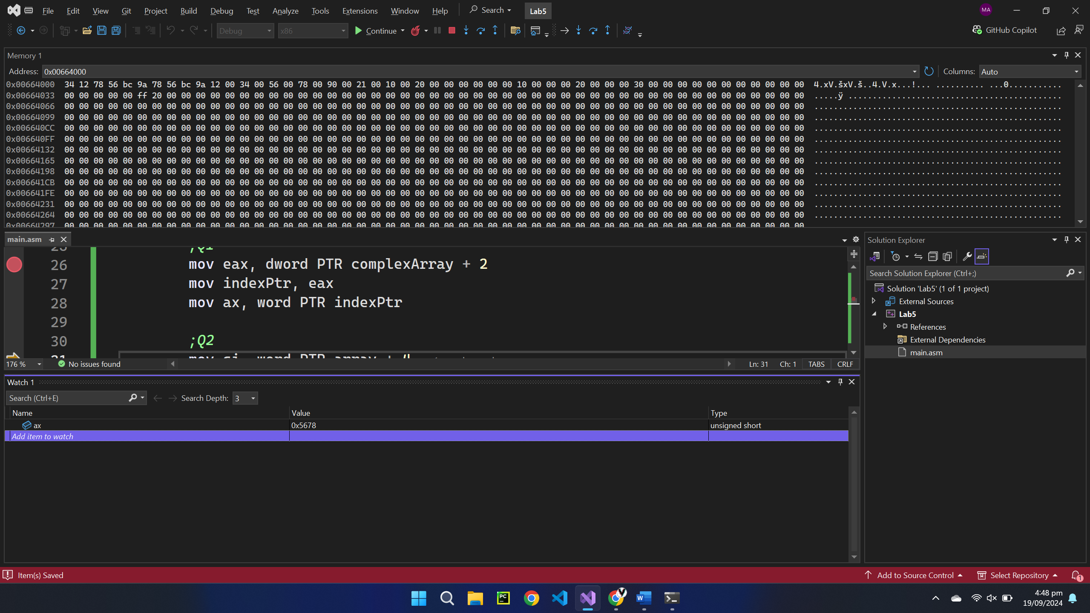

Q3) 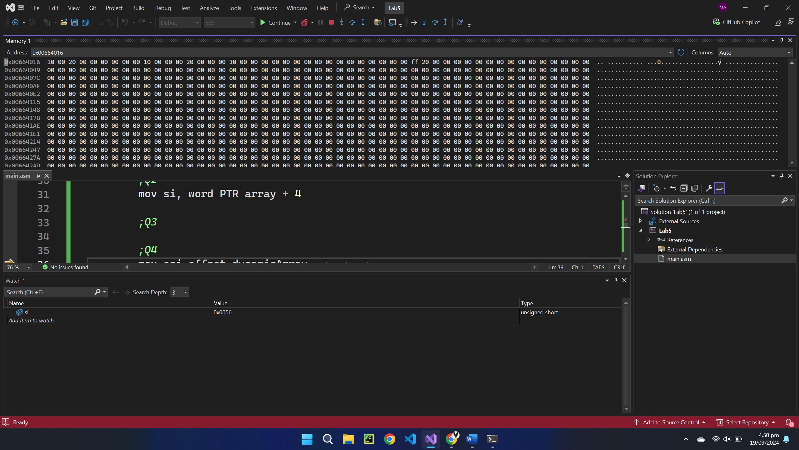

Q4) 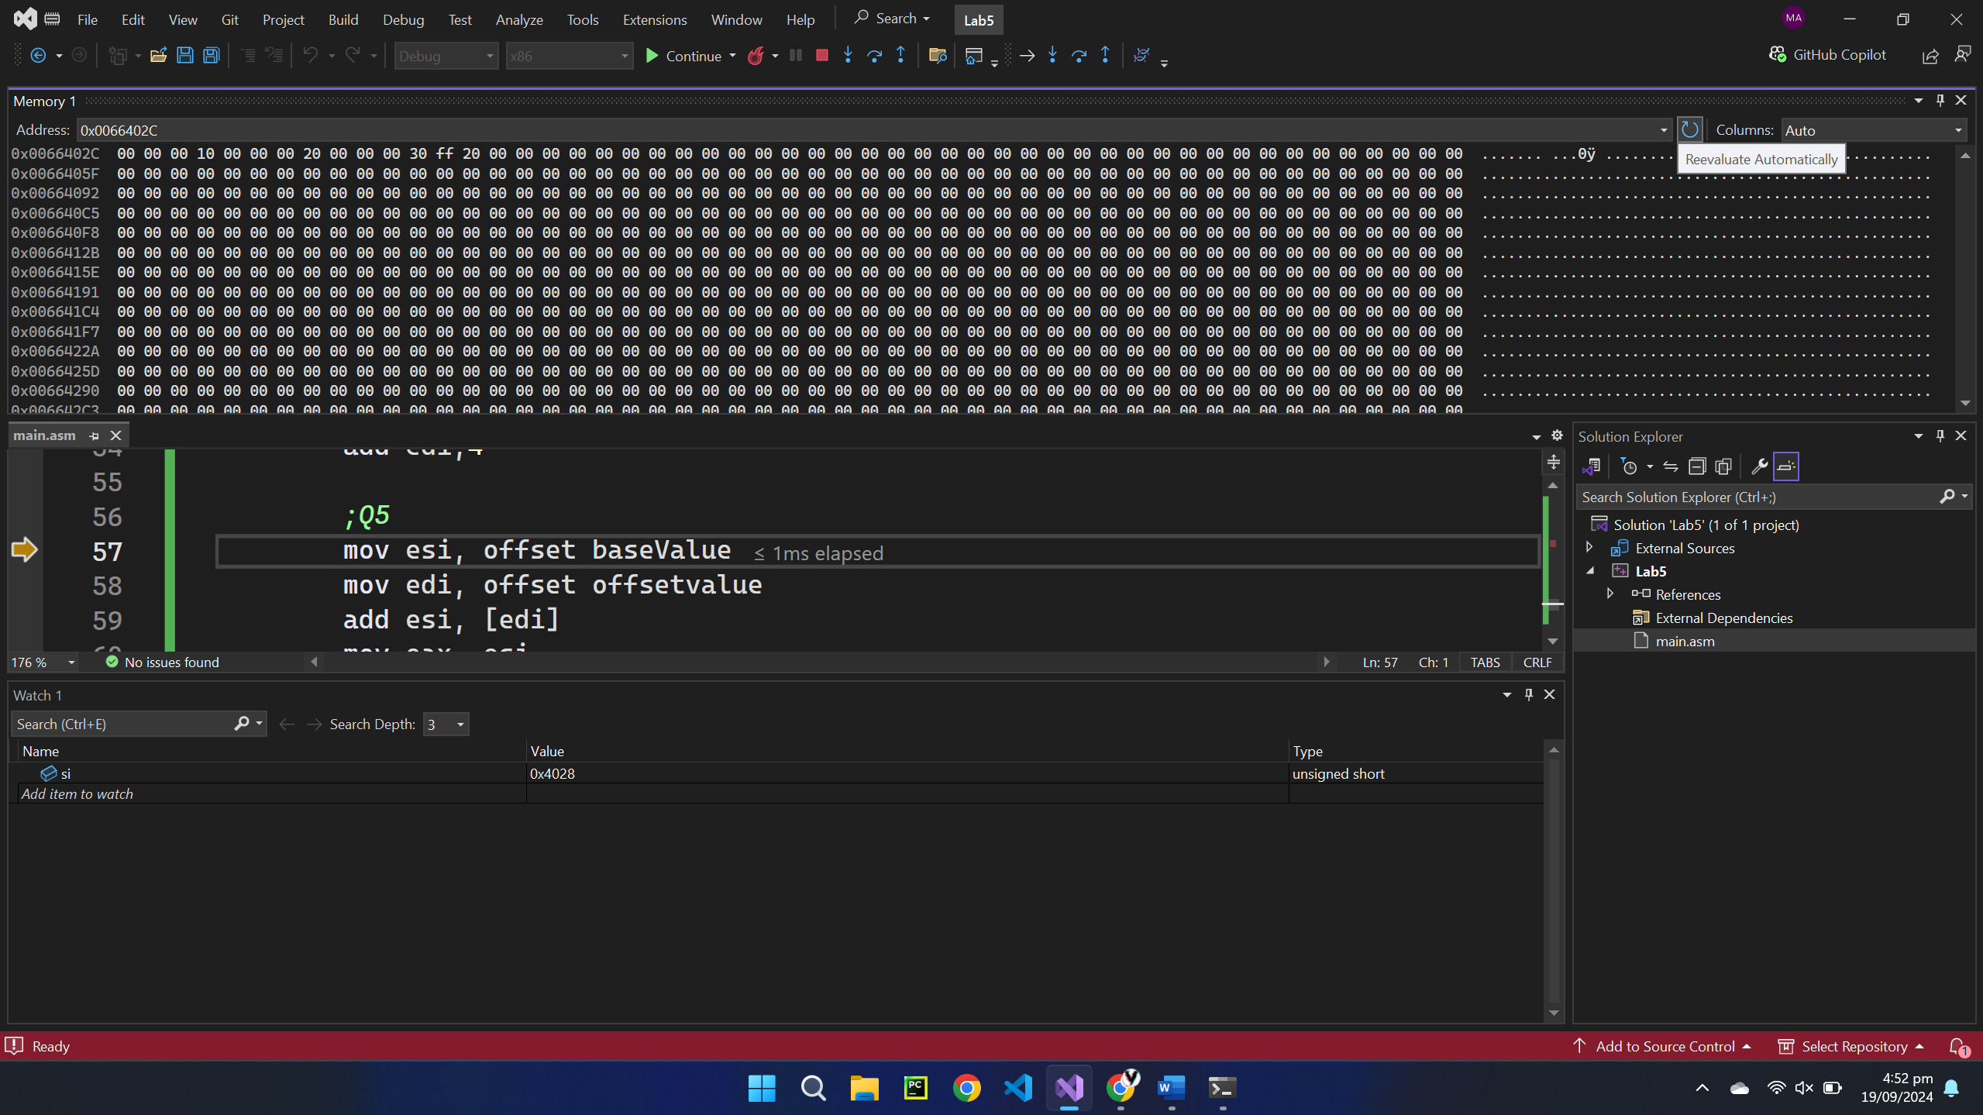

Q5) 